1. *Change the following phrases into valid MATLAB® variables (enter your answers in a Word doc as described here): numer@tor, day of week, a/b, 3b, _x_1, %diff.*

numerator

day_of_week

a_over_b

x_1

percentDiff

1. Use the DIARY command to capture your work through of exercises 2.1 – 2.8 on page 36-37 of the textbook. Save the diary session in a file named "A2_2_LastName.txt".

**Exercise 2.1**

Decide which of the following numbers are not acceptable in MATLAB, and state why:

(f) 3.57e2.1

↑

e can only be used with integer values.

**Exercise 2.2**

State, giving reasons, which of the following are not valid MATLAB variable names:

(a) a2

(b) a.2

All three of these options use invalid characters and result in an “invalid Expression” error.

(c) 2a

(d) 'a'one

(e) aone

(f) _x_1

The underscore is an illegal starting character.

(g) miXedUp

a space denotes the end of a variable, literal, or expression and cannot be used for one name.

(h) pay day

(i) inf

(j) Pay_Day

(k) min*2

(l) what

**Exercise 2.3**

Translate the following expressions into MATLAB:

(a) Image

p + (w/u)

(b) Image

p + (w/(u+v))

(c) Image

(p + (w/(u+v)))/ (p + (w/(u-v)))

(d) Image

x^(1/2)

(e) Image

y^(y+z)

(f) Image

x^(y^(z))

(g) Image

(x^y)^z

(h) Image

(x-(x^3)/factorial(3)) + ((x^5)/factorial(5))

**Exercise 2.4**

Translate the following into MATLAB statements:

1. Add 1 to the value of i and store the result in i.

i = i+1

1. Cube i, add j to this, and store the result in i.

i = (i^3)+j

1. Set g equal to the larger of the two variables e and f.

g = max(e, f)

1. If d is greater than 0, set x equal to −b.

g = max(e, f)

(e) Divide the sum of a and b by the product of c and d, and store the result in x.

x = (a+b)/(c*d)

**Exercise 2.5**

1. n + 1 = n;

the left hand side must be a single variable in any assignment statement.

1. Fahrenheit temp = 9*C/5 + 32;

A space is an illegal character if placed between valid alphanumeric characters.

(c) 2 = x;

A variable cannot be stored in a literal.

**Exercise 2.6**

2.6 Write a program to calculate *x*, where

Image

and Image, Image, Image (Answer 3.0)

**Exercise 2.7**

2.7 There are eight pints in a gallon and 1.76 pints in a liter. The volume of a tank is given as 2 gallons and 4 pints. Write a script that inputs this volume in gallons and pints and converts it to liters. (Answer: 11.36)

**Exercise 2.8**

Write a program to calculate gasoline consumption. It should assign the distance traveled (in kilometers) and the amount of gas used (in liters) and compute the consumption in km/liter as well as in the more usual form of liters/100 km. Write some helpful headings so that your output looks something like this:

Distance    Liters used       km/L    L/100km

  528         46.23          11.42     8.76

1. Use the DIARY command to capture your reproduction of the statements listed in section 2.3.2 of the textbook on page 38. Save the diary session in a file named "A2_3_LastName.txt".

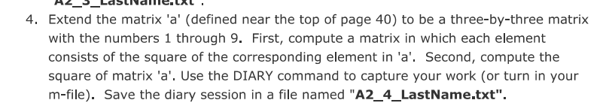

1. 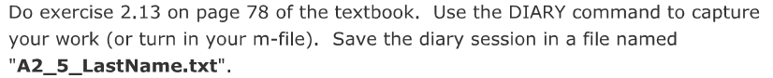

2.13 Set up a matrix (table) with degrees in the first column from 0 to 360 in steps of 30, sines in the second column, and cosines in the third column. Now try to add tangents in the fourth column. Can you figure out what's going on? Try some variations of the format command.

1. Text

   Description automatically generated



The key difference that can be observed in the above matrices is the following. For a matrix of strictly real numbers the transpose operation simply rearranges the columns into rows and vice versa. However, in the complex case of matric **c** we can observe that there is a reversal of sign of the complex portion of the numbers. This is the case such that the multiplication property of the transpose operation may be preserved in the complex case. Specifically (AxB)’ = B’ xA’

Which we can show this in MATLAB.

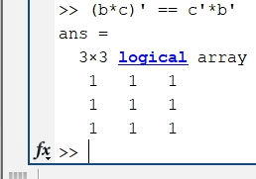

Completed in MATLAB see attached file

1. Text

   Description automatically generated

Completed in MATLAB see attached file

9.

10.



See attached MATLAB code

